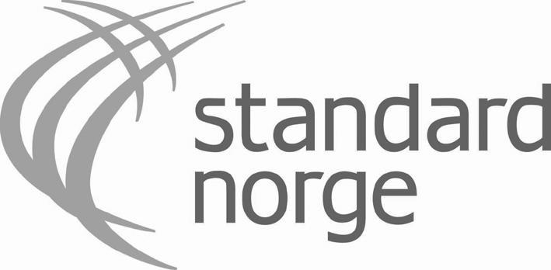

SEMINAR
SAFETY OF CHILD PLAYGROUND AND SPORT FIELDS
Prague 2010-11-05

OPENING WORDS
Merete H. Murvold, Standards Norway

Dear ladies and gentlemen
First of all, to Mr. Libor Dupal: Congratulations on organizing this seminar with focus on child safety in playground and sports fields.

I am happy to be here at this seminar and I am looking forward to our discussions during the day in this important area for European consumers.

Standards Norway, the Norwegian member of CEN and ISO, have had the pleasure to participate in a project led by the Czech Consumer Association during the last 2,5 years. As a result of the project, the Cabinet for Standardization was established in 2009. This year we have focused on involvement of consumers when implementing regulations and standards and specific child safety in relation to playgrounds and sports fields.

We have organized two project meetings in Prague and Oslo this year and exchanged experience and challenges and in that way given new ideas in how to solve common matters for consumers in the Czech Republic and in Norway related to this area. It has been a very good two-way discussion where we have learned a lot both of us, and we realize that the challenges we face are very much the same, and probably is all over Europe. We have also discussed consumer participation in the standardization process. Consumer representatives need to be involved in the standard making process, from start to end, to make sure that consumer requirements are included. Consumers can really make a difference by attending the work. And a mixed group of experts is necessary to identify all aspects on a subject.

This project has been of great value for my colleagues and me in Standards Norway and given important input to the consumer work within my organization. It has been a great pleasure. Standardization is a way of bringing Europe together - in the same way as this project.

I wish us an interesting seminar.

Thank you very much.

